Day 31 - 06th Sept 2025

DynamoDb Architecture:

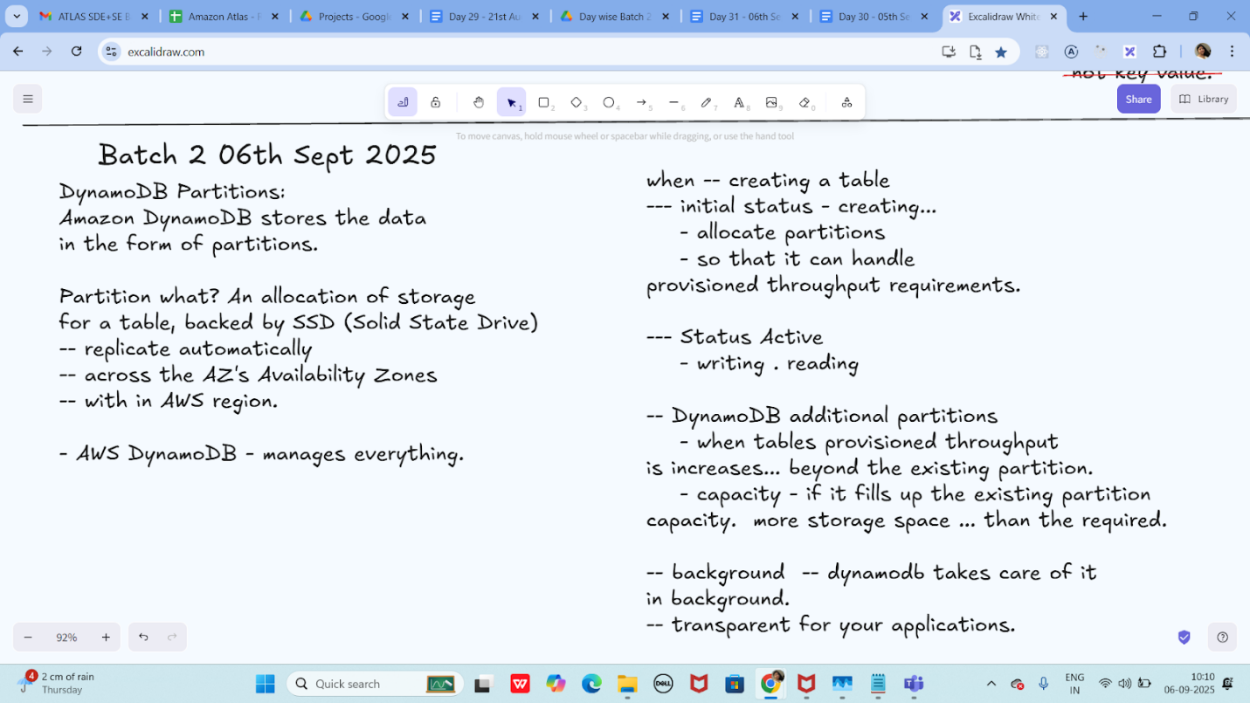

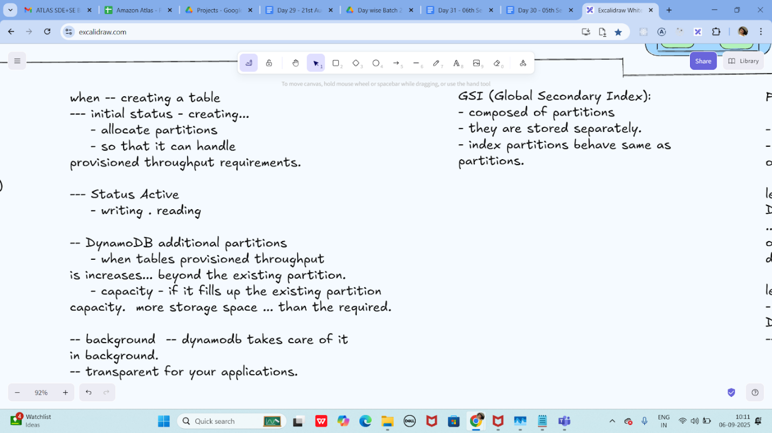

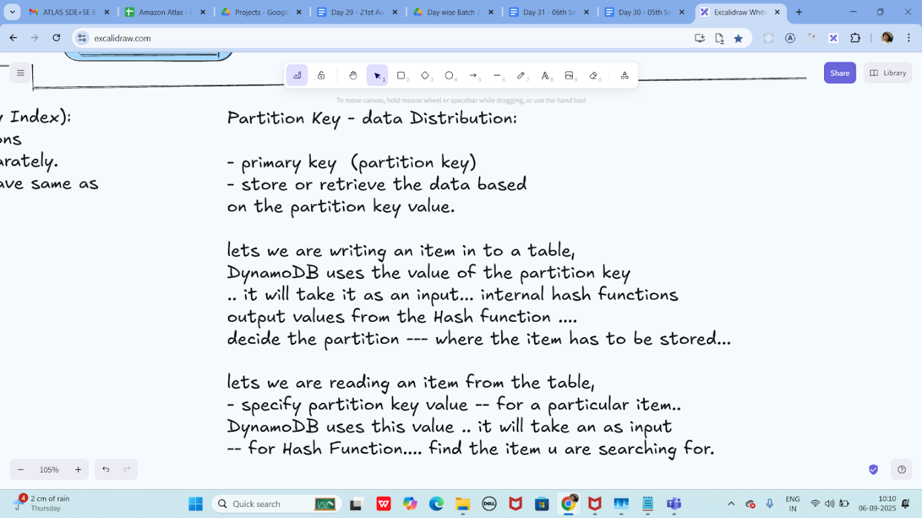

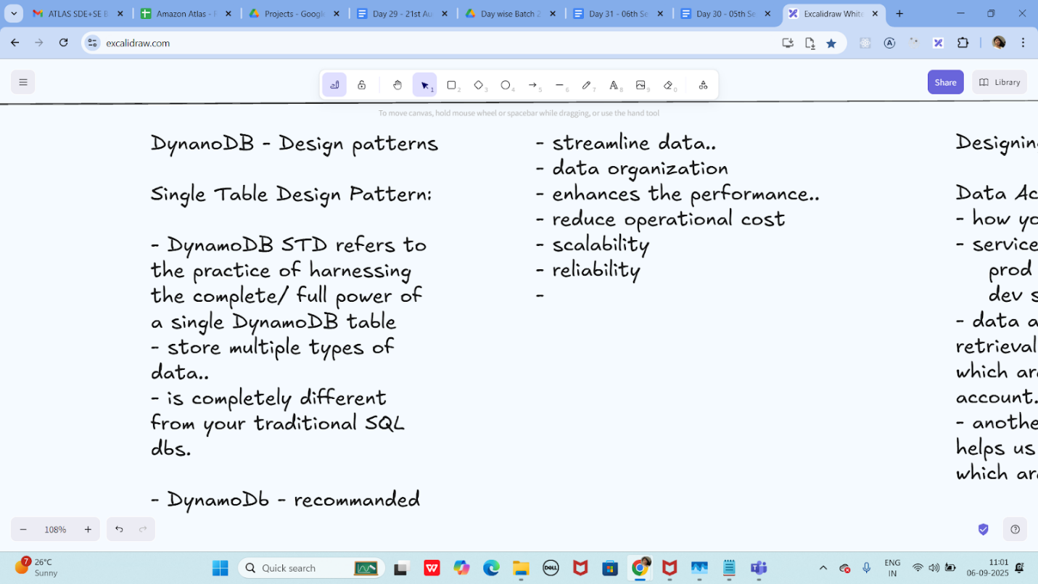

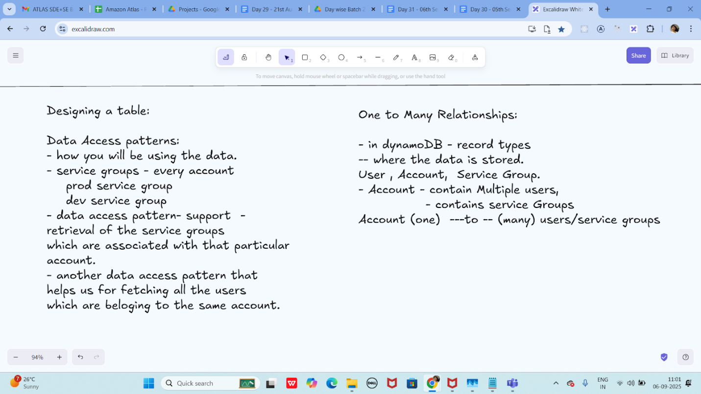

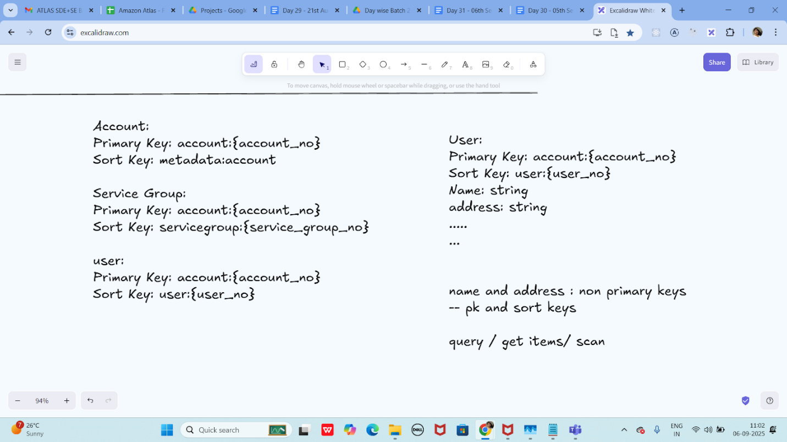

EC2 AWS and Features of EC2

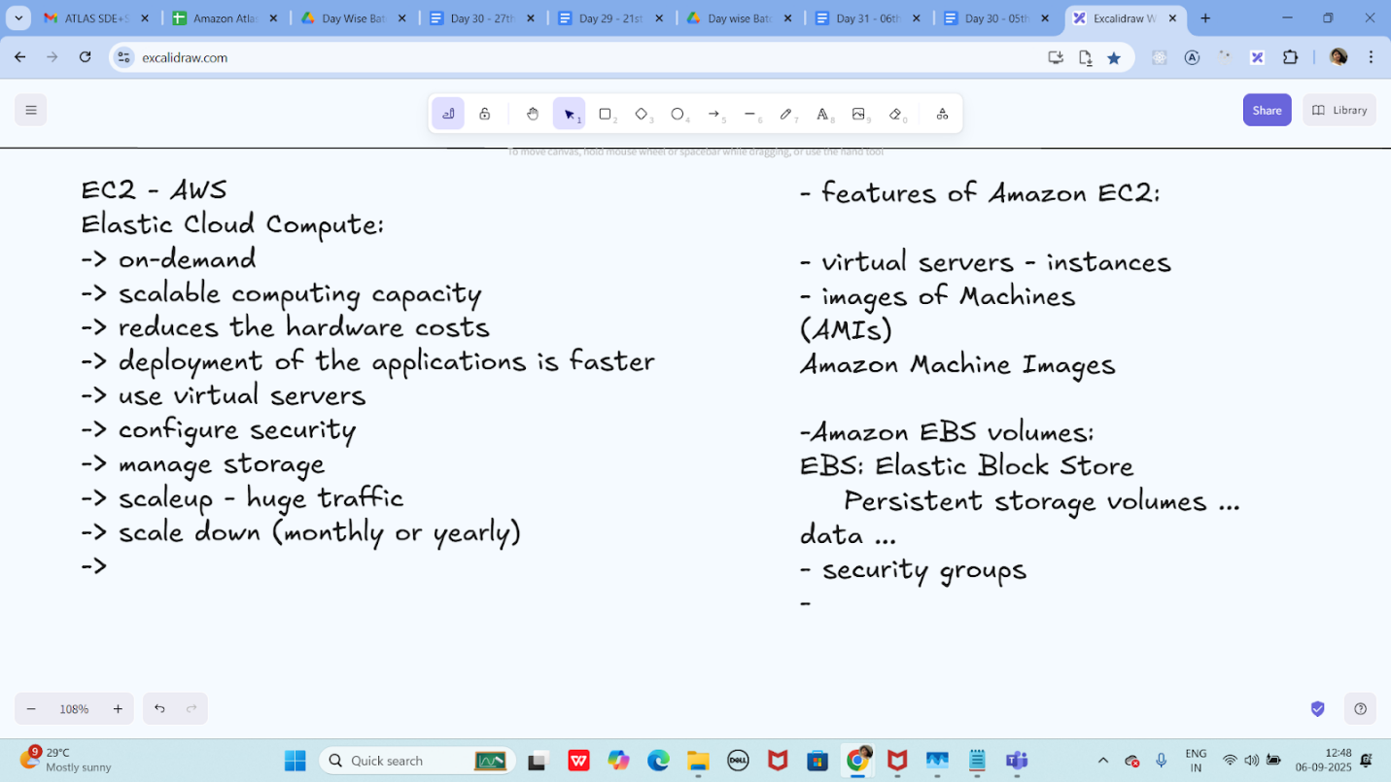

CAP Theorem:

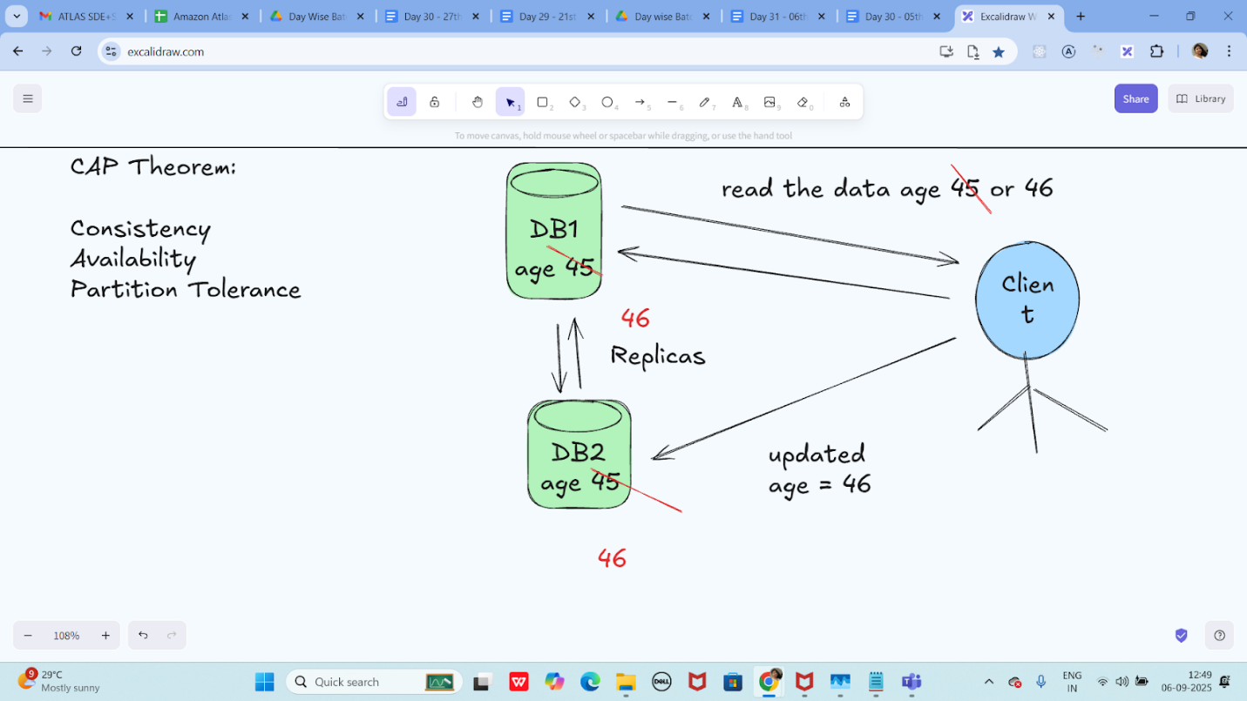

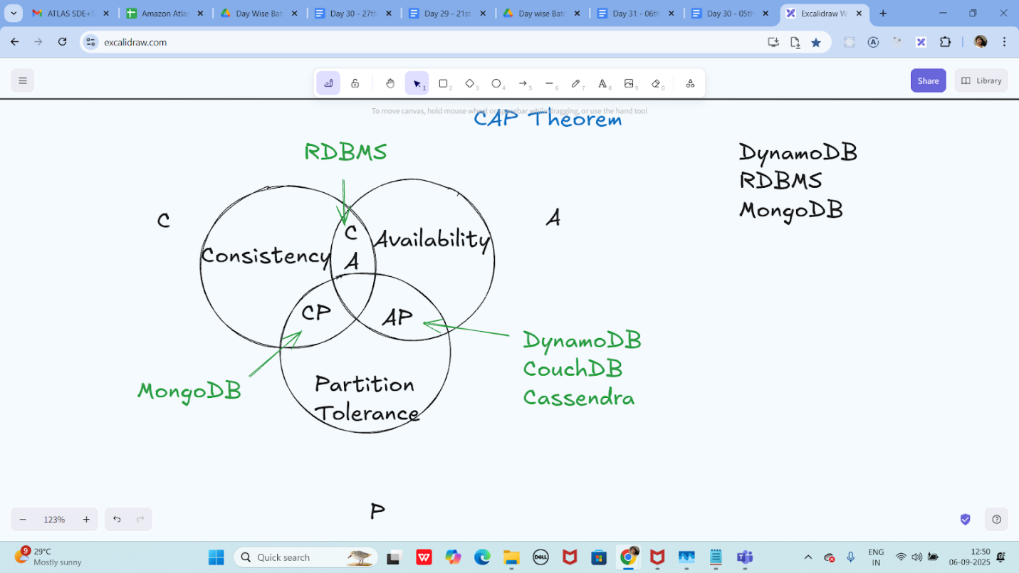

ACID and BASE Properties:

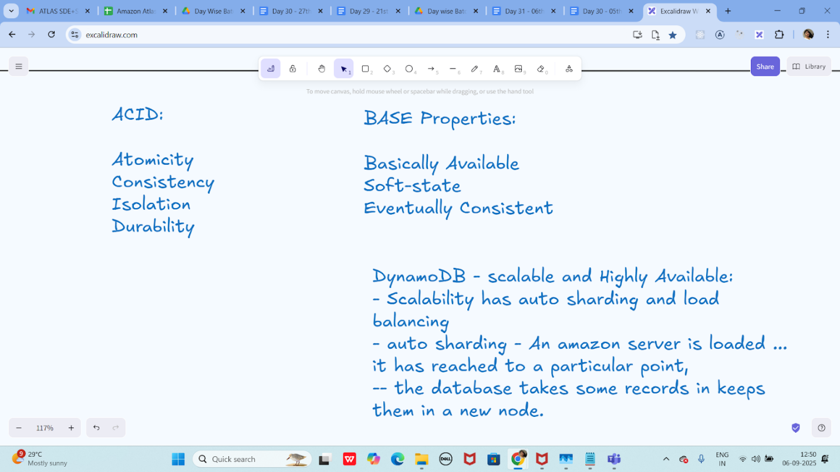

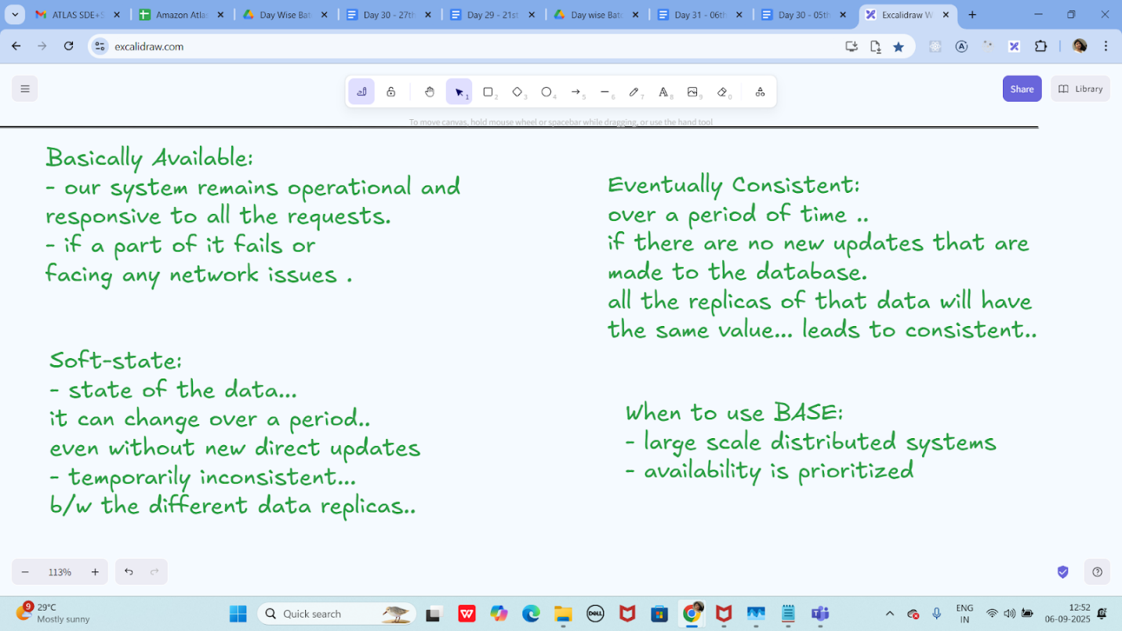

Info Box:

Excalidraw updated at 10.12

<https://excalidraw.com/#json=NwMX_ny4Q1qCV5DM1yAGu,uuB0ScTcUq0RTVkO_l7kzg>

Excalidraw updated at 11.00

<https://excalidraw.com/#json=E16UWRzUEqN--IRghiObH,DlKr2ErHsvVE_VHCPGeIpw>

Exalidraw updated at 12.48

<https://excalidraw.com/#json=i0mtFw6D_reATbbH3_10L,xUjM-HZa1iqDsXXEkaKYFA>

Add ons:

Day 31 - 07th sept 2025 - DynamoDB

My Server is at C:\Program Files\DynamoDB\DynamoDB_local>

So open cmd at that location and run below command

Run the Server

java -Djava.library.path=./DynamoDBLocal_lib -jar DynamoDBLocal.jar -sharedDb

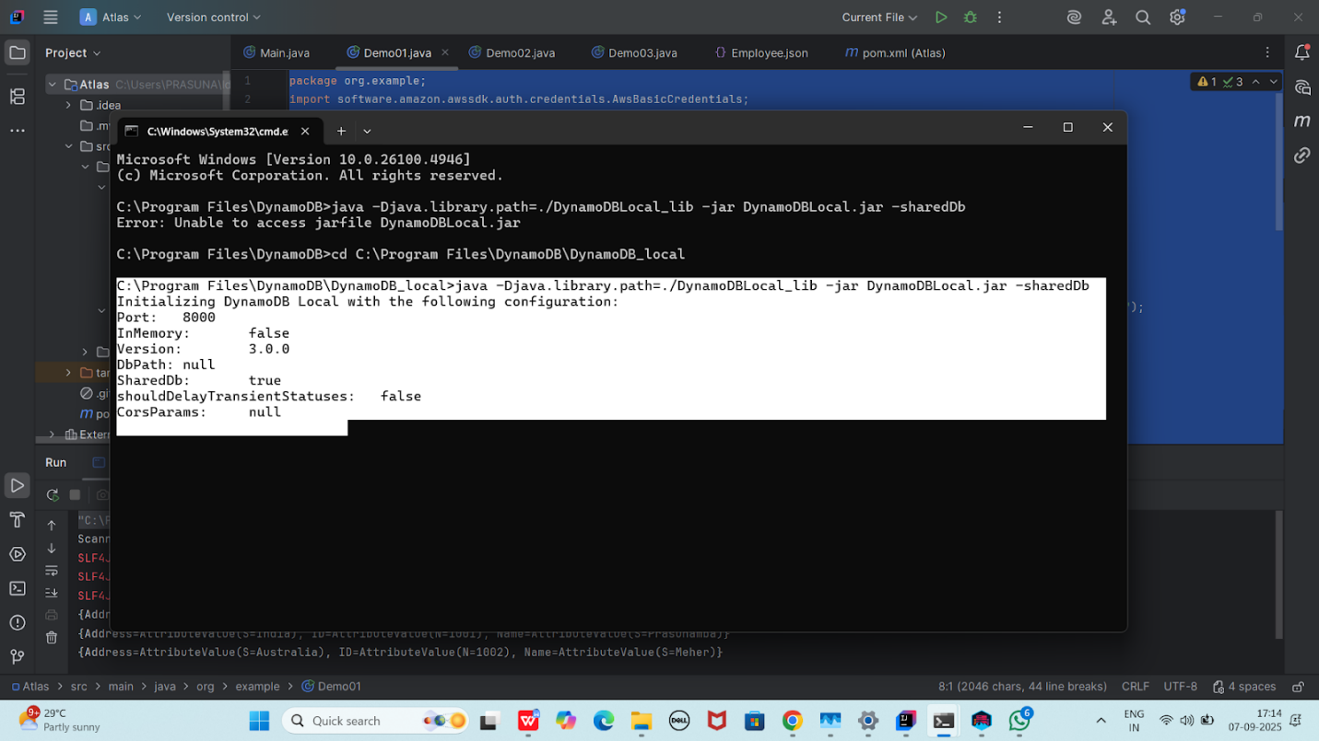

Pom.xml

<dependencies>

   <!-- AWS SDK v2 for DynamoDB -->

   <!-- https://mvnrepository.com/artifact/software.amazon.awssdk/dynamodb -->

   <dependency>

       <groupId>software.amazon.awssdk</groupId>

       <artifactId>dynamodb</artifactId>

       <version>2.33.4</version>

   </dependency>

   <!-- Jackson (for JSON) -->

   <dependency>

       <groupId>com.fasterxml.jackson.core</groupId>

       <artifactId>jackson-databind</artifactId>

       <version>2.17.2</version>

   </dependency>

</dependencies>

  <dependency>

       <groupId>org.slf4j</groupId>

       <artifactId>slf4j-simple</artifactId>

       <version>1.7.36</version> *<!-- Use the latest stable version -->*

   </dependency>

Task 01

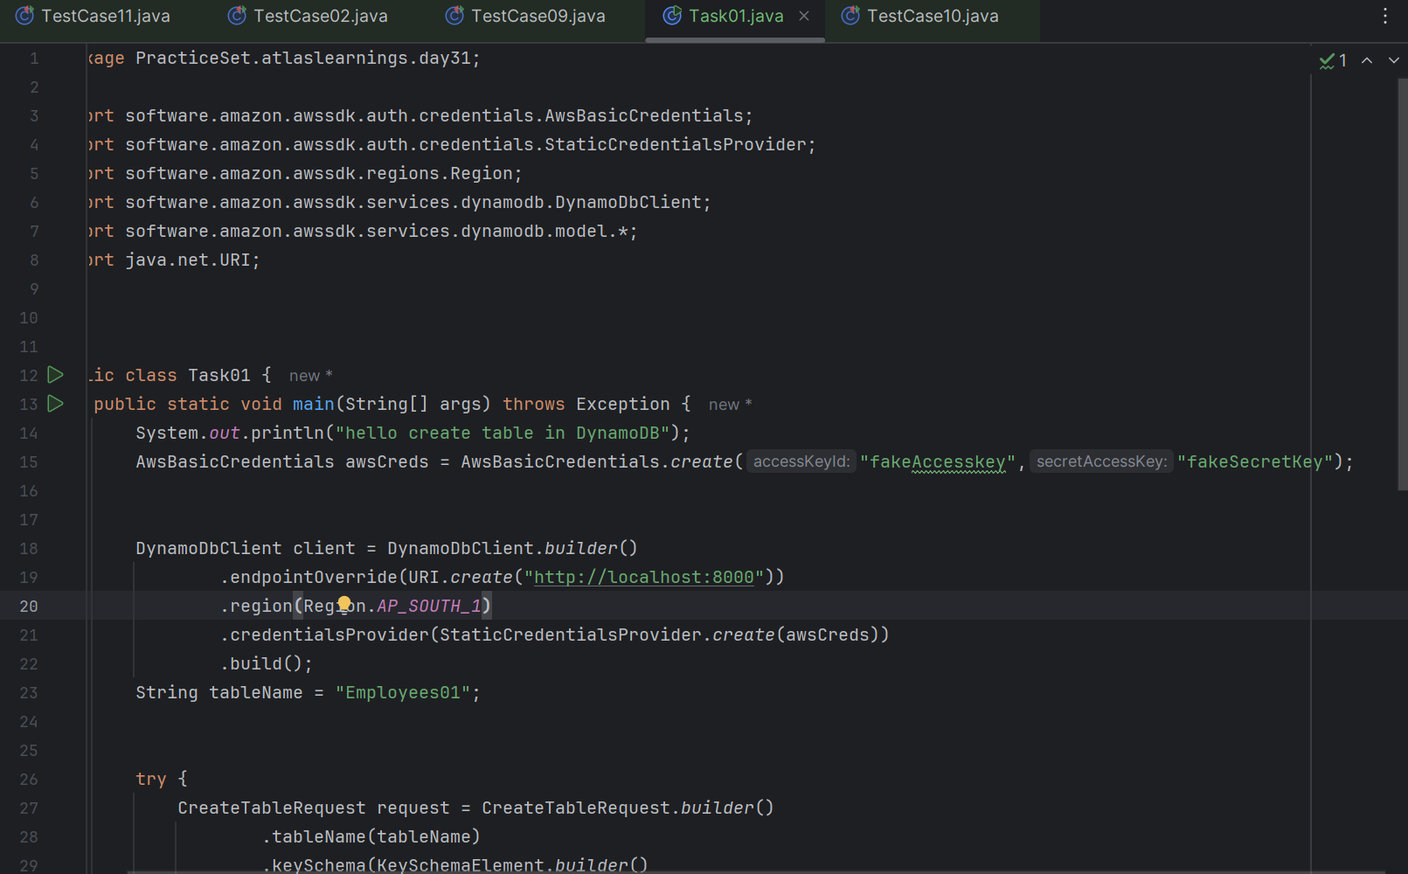

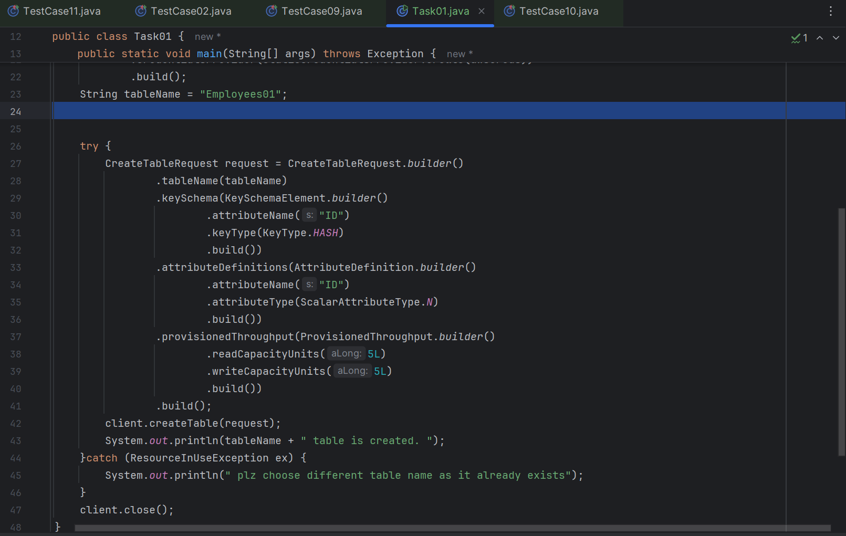

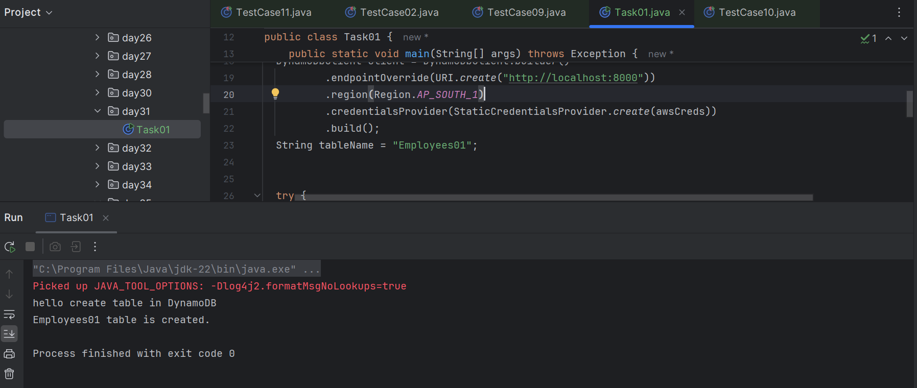

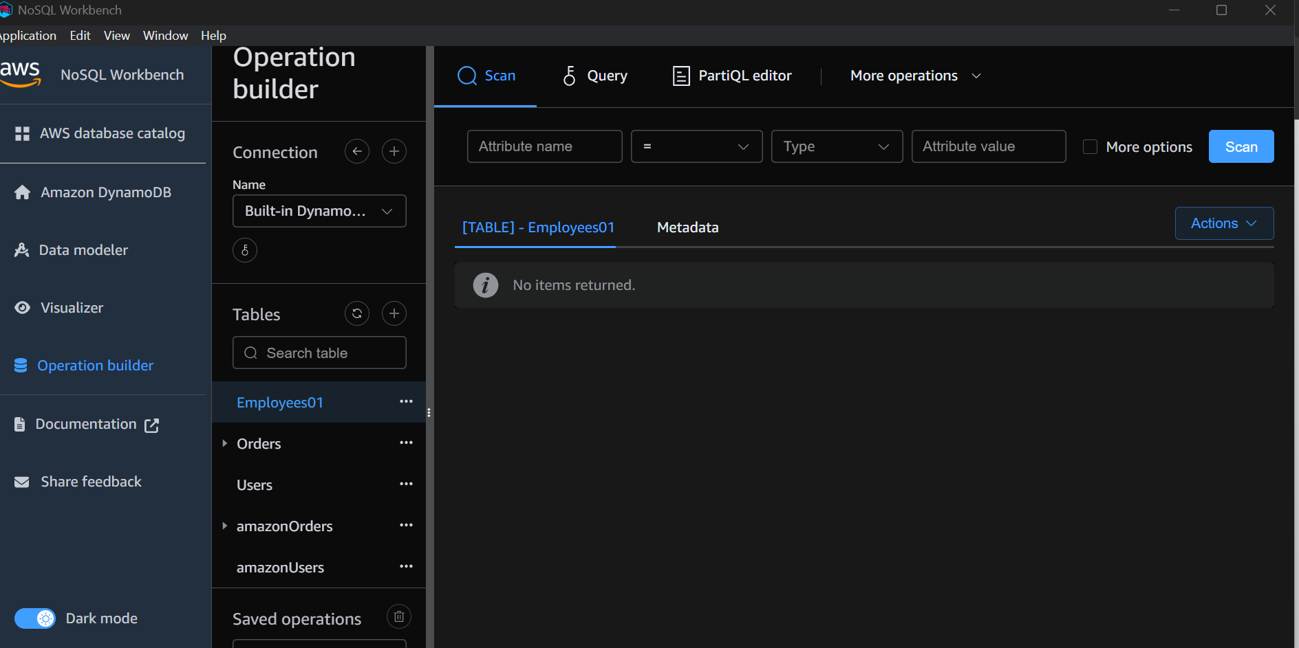

Task 02

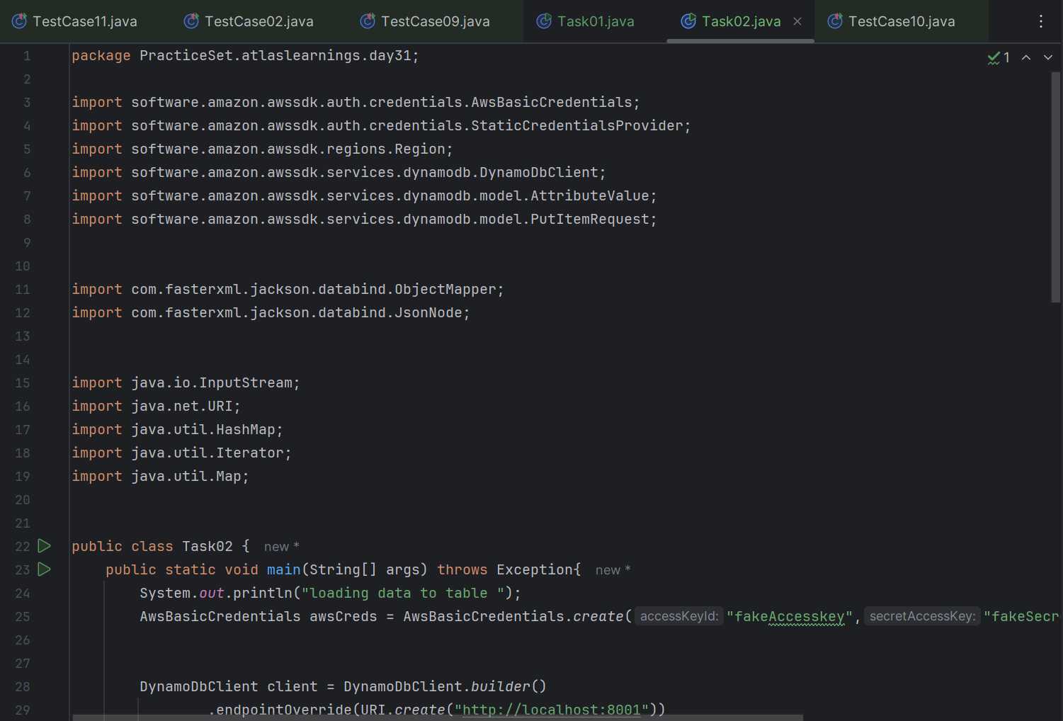

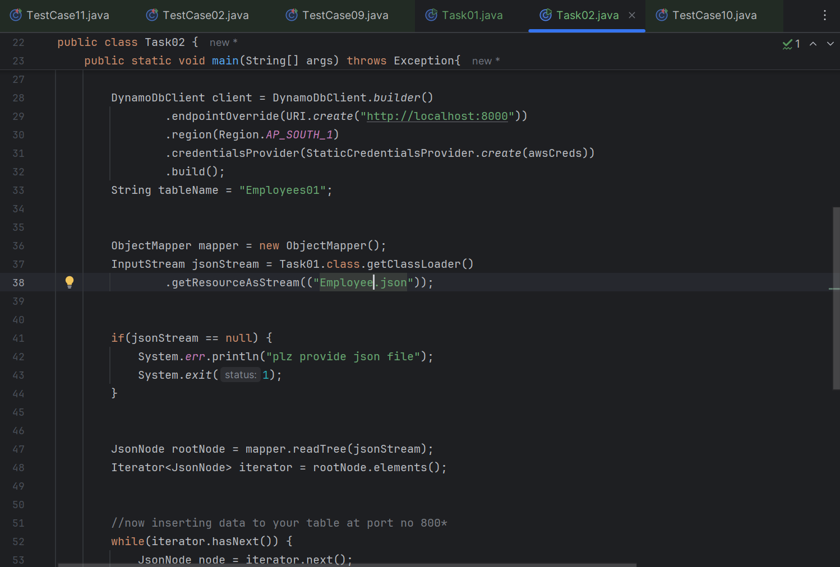

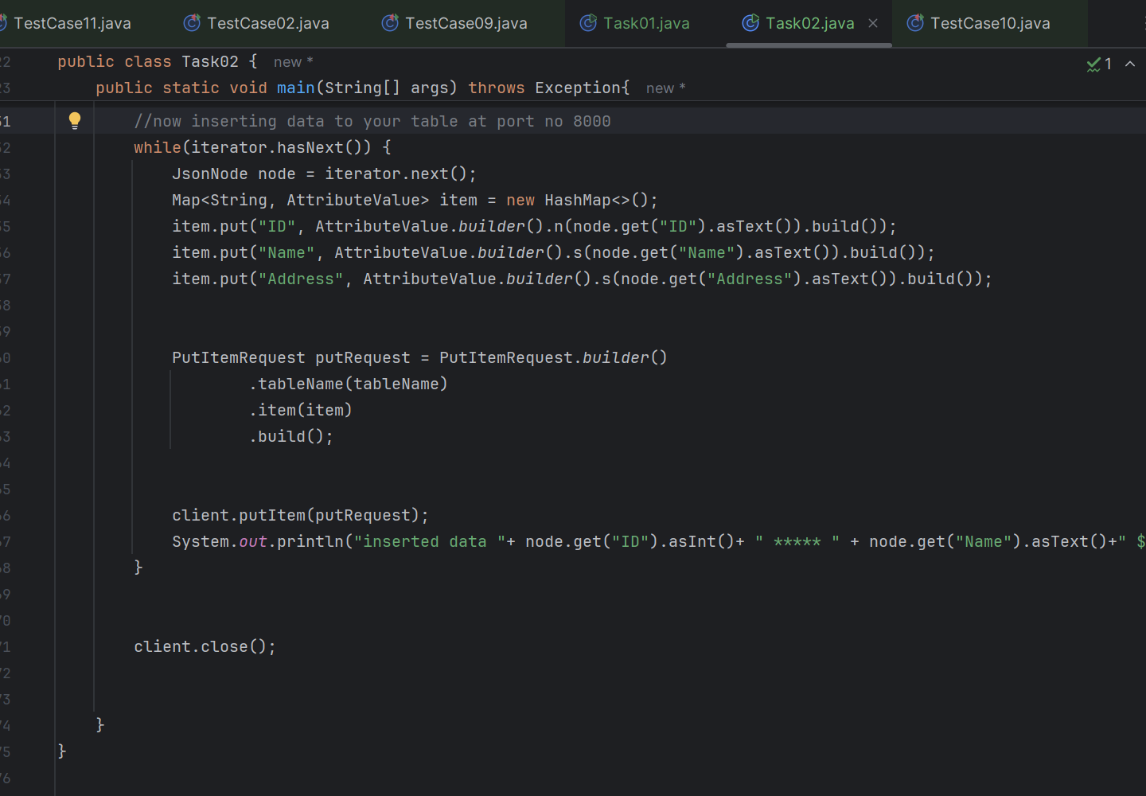

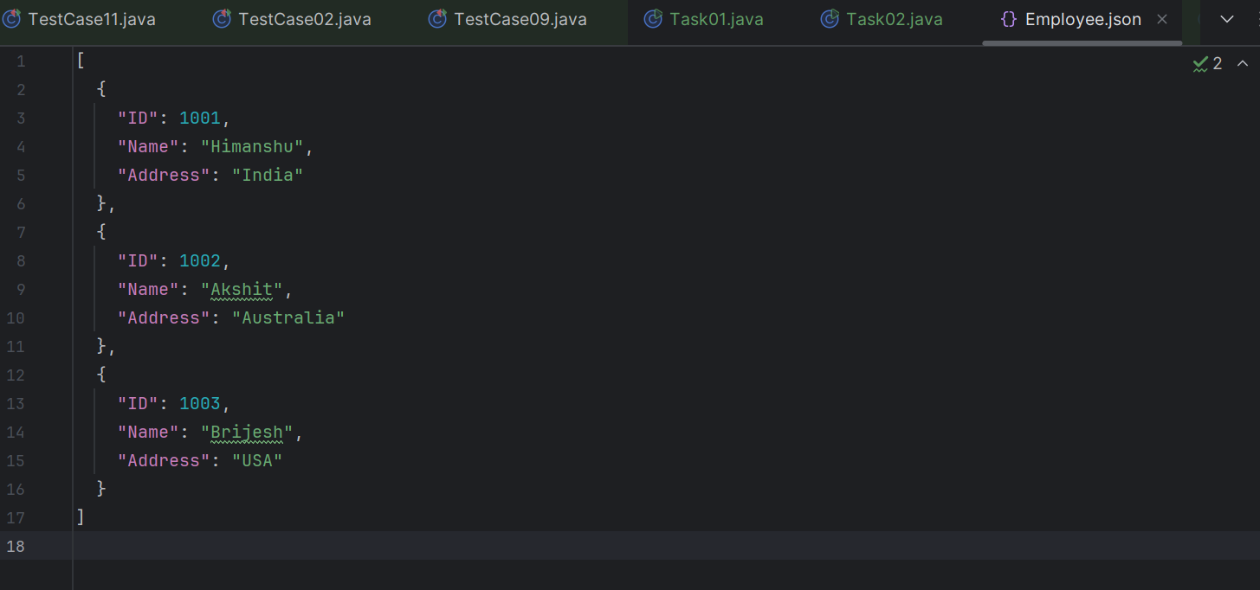

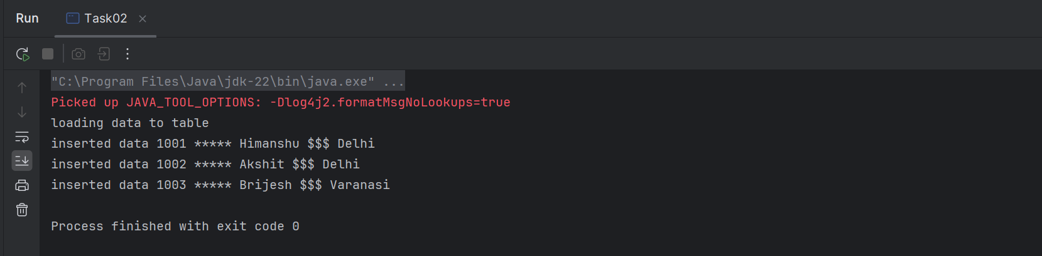

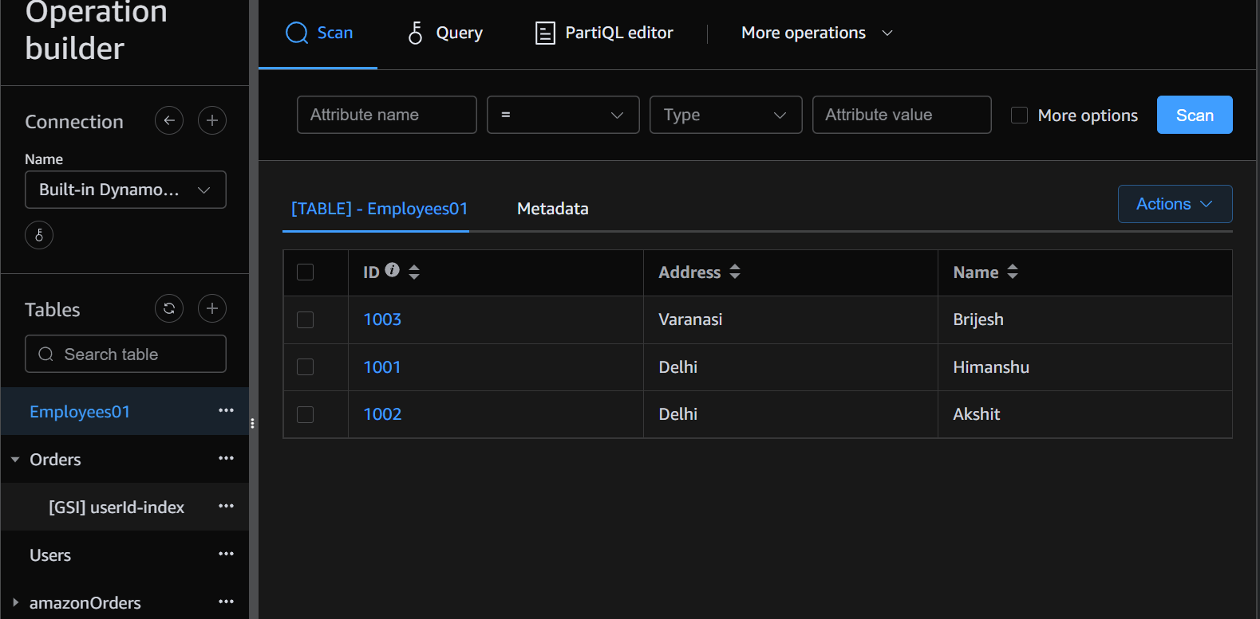

Task 03

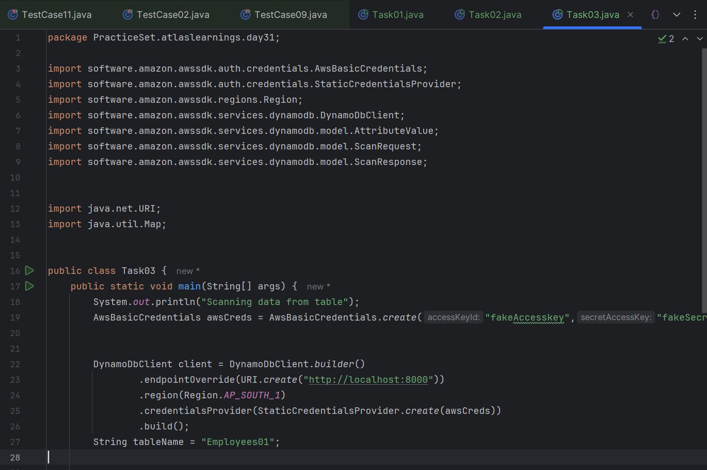

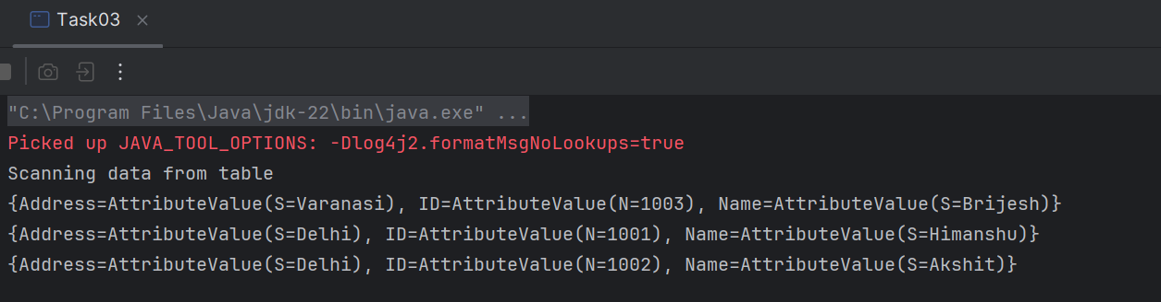

Task 04

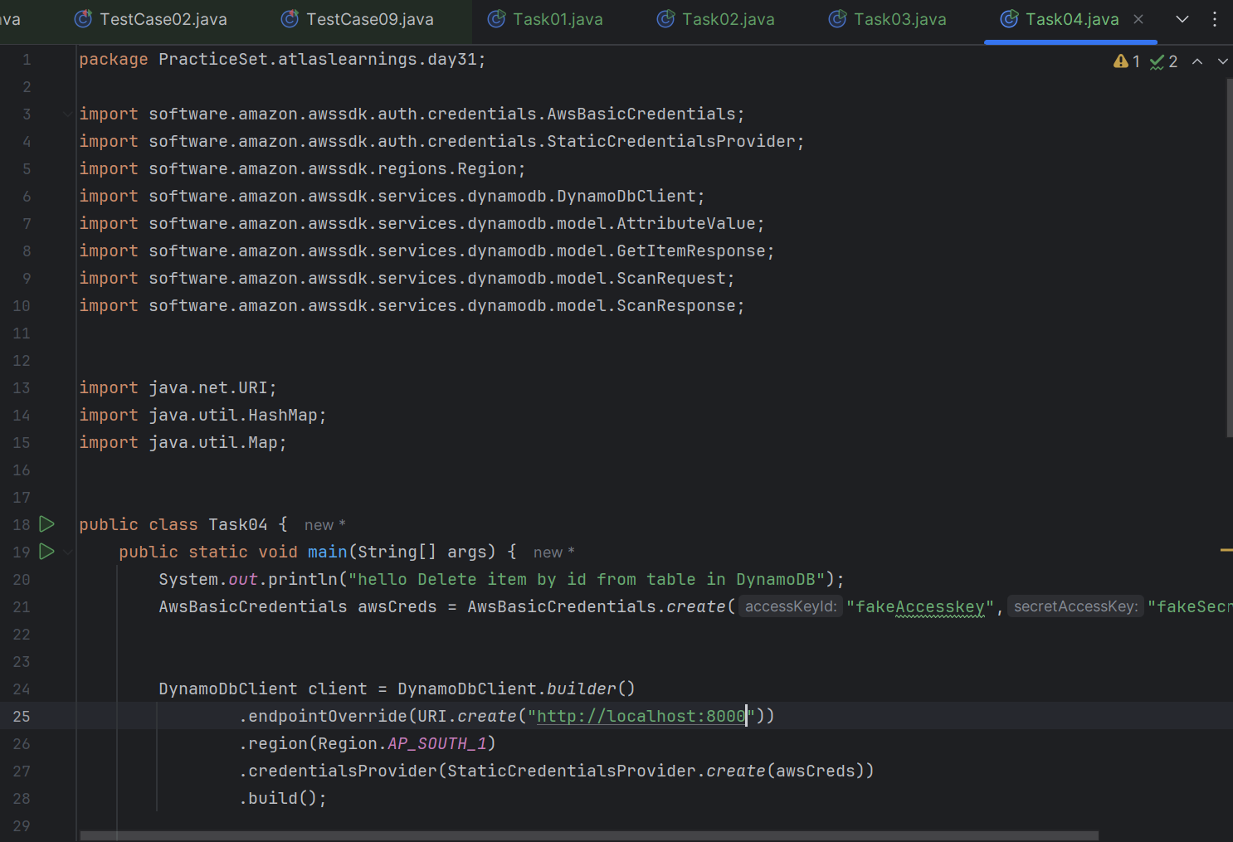

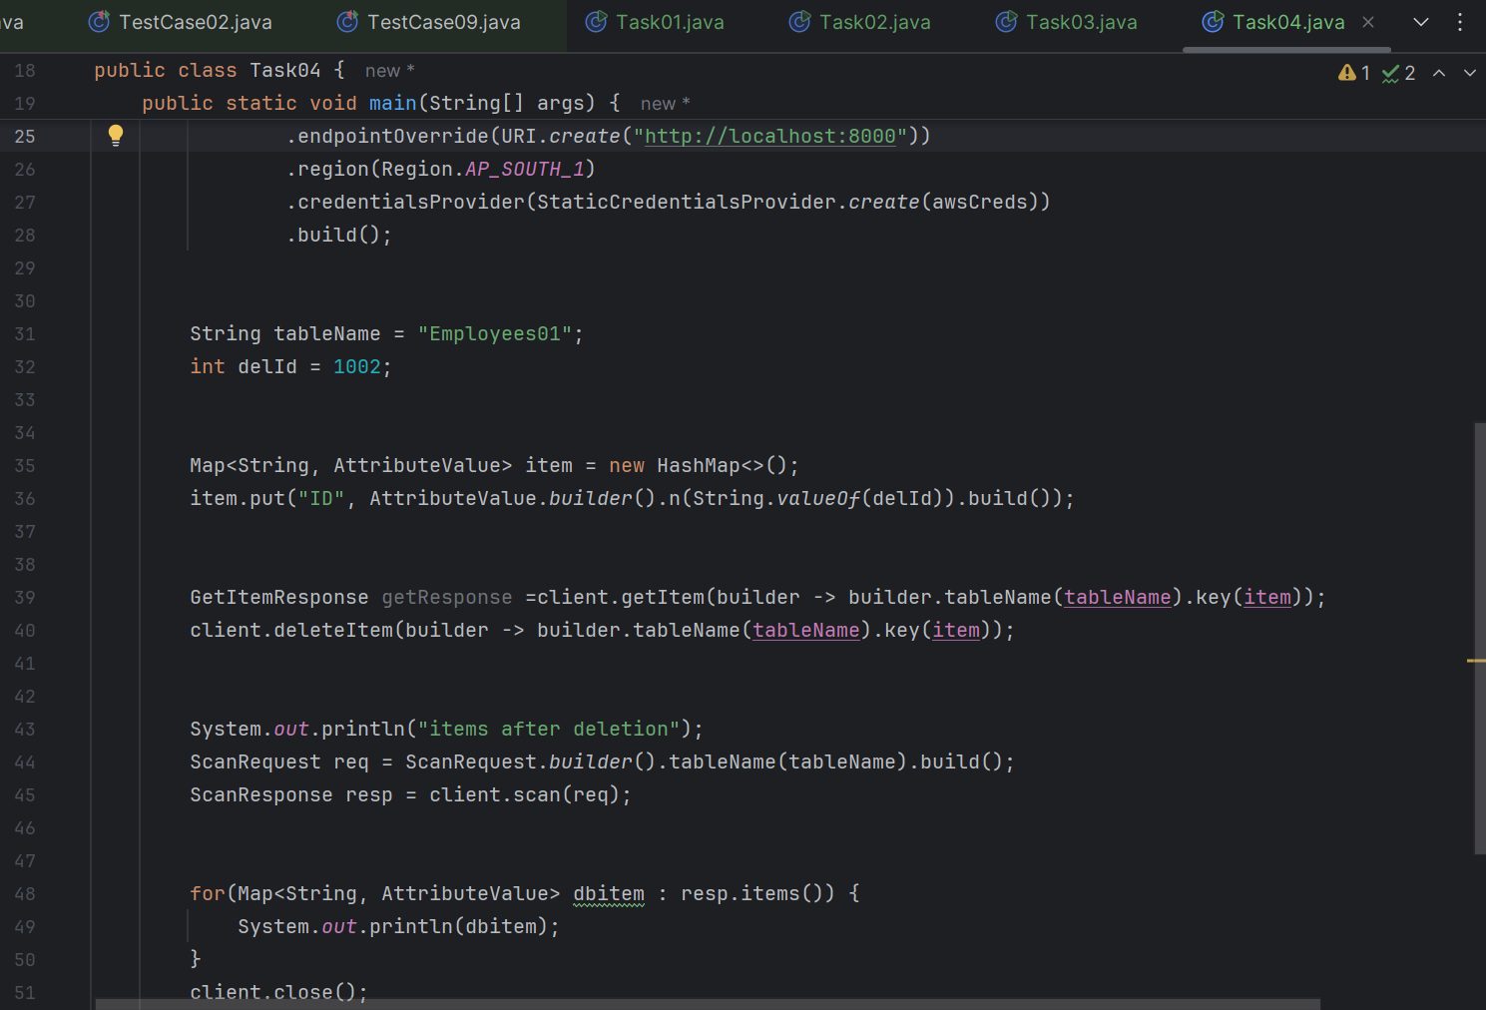

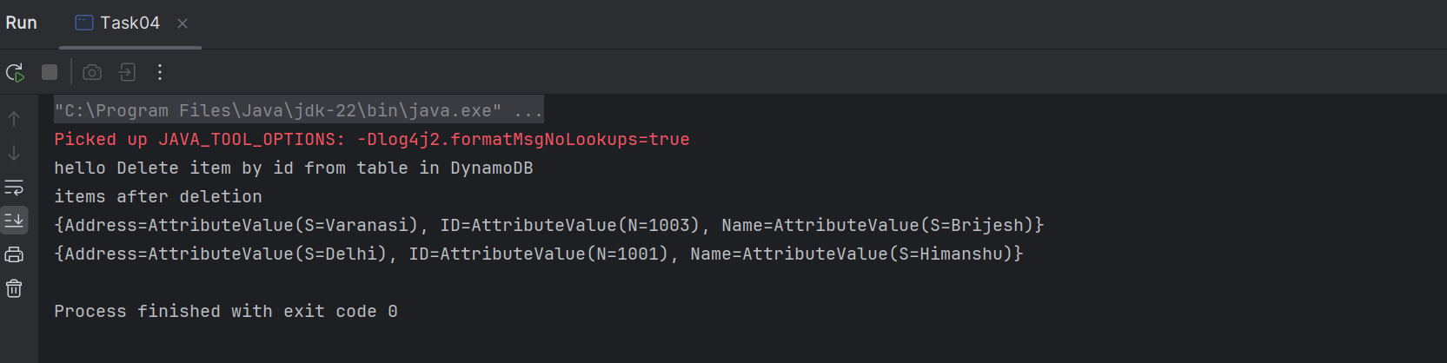

Task 05

